**Implementation of Dynamic Routing in a campus network**

Simranjeet Singh

Bachelor of Computer Science

(Chandigarh University)

**Abstract**

**Network security is a vast subject and plays a crucial and essential role in the global network, which is mainly used by beginners and experts. The increase in network security various algorithms and functions are used. On the global network, millions of users communicate and pass the messages to each other on the Internet.** **The very nature of the Internet makes it vulnerable to attack. Several hackers and viruses enter the system and use the data for their unauthorized work. Now the days, Growth in business uses the network in which security plays a very vital role in the global network. In this project, we use the number of security techniques to secure the global network. Therefore it is very necessary to make a secure global network to overcome with unauthorized access. Numbers of authentication and firewalls are used to control the access in the network.**

1. **Introduction**

Security in the network plays a very critical role in every company and organization. Interconnection of the multiple devices using an optimal path for sending and receiving messages or data which is meant by network. To secure the messages and data which are transferring from one user to another using different technique is called security. Growth in revenue, e-business plays an essential role and the efficiency is improving day by day. To improve efficiency and combat those threats the need for security is very much important. Network security is provided to the unauthorized network. Advanced security technique used in global network plays a very important role in the future.

1. **Security in Global Network**

* **Access Control List (ACL)-:** These filters are used to control the routing updates and packets are permitted or denied to access the data and websites. We use the ACL to block unauthorized websites and users. The unauthorized e-mails should be blocked by this technique. We can provide the ACL to all the router and network protocols just to provide the security. Basically, it can be configured to control network traffic.
* **Network Address Translation (NAT)-:** NAT is the method that translates the IP-Addresses in a local network to a single IP-Address and that IP-Address is used by the routers to connect the computer with the internet. This technique is used to control the access and provides the securities.

1. **Experimental Setup**

In this project, I have linked connections using different topologies like bus, tree, and star. Different topologies are used to design networks in different blocks. Telephones can also be used as a mode of connections in different countries during an emergency. All telephones are connected to each other and have a specific number to call each other. Topologies are connected using Static Routing, Rip Routing, and EIGRP Routing. IP Addressing is done by the DHCP pool method in which an IP address is given to a pc automatically. All the designing part is complete. We can communicate with different clients at any time and can send messages. During the communication, the data has to transmit securely.

It should also identify the user and provides the communication according to the prescribed level of security. With the transfer of the file requested and run the required process at the server if necessary. In this system, the data will be sent as audio through the network.

**Flowchart:**

DHCP protocol

Access filter applied

NAT applied

Two way authentication

Delivered

**Results**

As time goes on, the new technologies are coming. So, it is very important to secure the data and packets which are sending and receiving by the users. In this project, the access-list blocks the unauthorized server’s IP-address. If the communication is secured which leads to increase development in e-business activities between different countries.

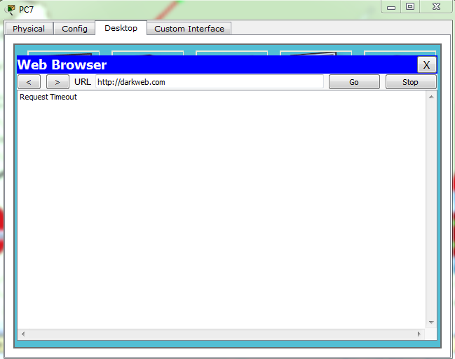

**Acknowledgment**

While presenting this report we would like to express my deep sense of gratitude to Assistant Professor Navpreet Kaur that was an indispensable part of my training giving me unending guidance, inspiration, encouragement and providing me an excellent environment throughout my training at Chandigarh University. The training was an extremely productive & enriching experience, not only technically but also from providing practical skills.

We are extremely thankful to her who had devoted a lot of time in guiding and supervising me during my training. We place our gratitude towards her valuable advice and guidance in carrying out this enjoyable and productive experience, which provided me a great opportunity to search for new horizons.

**References**

* <http://www.rroij.com/open-access/network-security-an-approach-towards-secure-computing-160-163.pdf>
* <https://techterms.com/definition/nat>
* <https://en.wikipedia.org/wiki/Network_security>
* <https://www.cisco.com/c/en_in/products/security/what-is-network-security.html>